The Role of Prostate Cancer Exosomes in Macrophage Differentiation

Honours Proposal

Jayde Ruelcke

Supervisor: Michelle Hill
Co-supervisor: Antje Blumenthal

Statement of Authorship
~~~~~~~~~~~~~~~~~~~~~~~~~~~~~~~~~~~~~~~~~~~~~~~~~~~~~~~~~~~~~~~~~~~~~~

I, Jayde Ruelcke confirm that the work presented in this research
proposal/research report has been performed and interpreted solely by myself except where explicitly identified to the contrary*. I confirm that this work is submitted in partial fulfilment for the degree of BSc Hons in Biomedical Science and has not been submitted elsewhere in any other form for the fulfilment of any other degree or qualification.

Word Count (excluding reference list, fig. Legends, tables and appendices):

Dated: 29/03/2012

Signature:
~~~~~~~~~~~~~~~~~~~~~~~~~~~~~~~~~~~~~~~~~~~~~~~~~~~~~~~~~~~~~~~~~~~~~~

* A student may often find that some work may be performed on their behalf. For example, histology preparations may be created by a member of the technical staff or surgery may be performed by another member of a laboratory. Such assistance must be accurately attributed and acknowledged.

I, Michelle Hill confirm that I have seen a copy of the work presented in this research proposal/research report as the supervisor of Jayde Ruelcke

Date: 29/03/2012

Signature: _________________________________________________________

Contents
Introduction 1
Background 2
Prostate cancer 2
The role of the immune system in targeting tumours 2
Macrophages differentiation determines the success of an immune response to tumours 3
In advanced prostate cancer there are an increased number of tumour associated macrophages 6
Prostate tumour associated macrophages act in a pro-tumour manner 7
Altered gene expression in advanced tumours facilitates in establishing an environment to differentiate macrophages 8
Altered secretion could establish a specific tumour microenvironment for macrophage differentiation 8
The role of caveolin-1 and PTRF in altering cellular secretion in the tumour microenvironment 9
Exosomes secreted in the tumour microenvironment provide a stable means to provide cellular communication 11
Hypotheses 13
Aims 15
Methods 15
Aim 1: Do exosomes induce macrophage differentiation? 15
Exosome induced differentiation of macrophages 16
Aim 2: How do the exosomes differ in PC3 cells with or without PTRF? 18
Aim 3: How are exosomes internalised by macrophages? 19
Data Analysis 20
Timeline 20
Significance 21
References 23

Included Figures
Figure 1 - Mechanisms of macrophage differentiation and their functional outcomes. 4
Figure 2 - The influence of PTRF and caveolin-1 on prostate cancer progression 10
Figure 3 – Proposed model of macrophage trans-differentiation 14

Included Tables
Table 1 - Relative protein abundance in PC3 cells with induced PTRF expression 11
Table 2 - Honours timeline 20

List of abbreviations
BFGF Basic Fibroblast Growth Factor
CCL2 Chemokine Ligand 2
CSF-1 Colony Stimulating Factor 1
ELISA Enzyme Linked Immunosorbent Assay
ICAM-1 Intercellular Adhesion Molecule 1
IFN-Gamma Interferon Gamma
IL-12, IL-23, IL-10, IL-1β, IL-6, IL-8 Interleukin - 12, 23, 10, 1-Beta, 6, 8
INOS Intermediate Nitrogen Oxide Species
LFA-1 Lymphocyte Function-Associated Antigen 1
LPS Lipopolysaccharide
miRNA micro Ribonucleic Acid
MMP Matrix Metalloproteinase
mRNA Messenger Ribonucleic Acid
MVB Multi Vesicular Body
NF-κB Nuclear Factor-Kappa B
NKT Natural Killer T Cell
NOS2 Nitric Oxide Synthase 2
PMA Phorbol 12-Myristate 13-Acetate
PSA Prostate Specific Antigen
PTRF Polymerase I Transcript Release Factor
RT-qPCR Real Time Quantitative Polymerase Chain Reaction
TAM Tumour Associated Macrophage
TNFα Tumour Necrosis Factor Alpha
VEGF Vascular Endothelial Growth Factor

The Role of Prostate Cancer Exosomes in Macrophage Differentiation

Introduction
Prostate cancer is a prevalent condition accounting for 6% of all diagnosed cancers . Their progression is mediated by the development of an immunosuppressive microenvironment. Late stage metastatic cancers sufficiently adopt multiple mechanisms in order to further spread and remain untargeted by the immune system. Immune modulation within tumours often enables recruitment of host defence mechanisms and either inhibits them or utilizes them for the tumours advantage. An instance of the latter occurs with macrophage differentiation. It has been seen that macrophages that infiltrate prostate tumours are differentiated to an immunosuppressive state . These are capable of altering the immune response with favourable outcomes for the tumour. This controlled differentiation of the monocytes into mature macrophages may be a result of the tumour microenvironment. Furthermore, cancerous cells may specifically signal to induce such differentiation by exporting cellular components via exosome release .

Background

Prostate cancer
Prostate cancer is the second most commonly diagnosed cancer in males. Progression then accounts for the fifth leading cause of cancer related deaths . At such stages the tumour has maintained a state of uncontrolled proliferation, angiogenesis and is typically metastatic . The cancer is most commonly found to metastatise to the adjacent bone and lymph nodes . This only occurs as a result of overcoming the body’s natural immune defence and is primarily achieved by modulating the functions of the innate and adaptive immune system .

The role of the immune system in targeting tumours
In proposed models of cancer immune surveillance, a tumour will only become metastatic if immunoediting progresses from stages of elimination and equilibrium to escape . The innate immune system may initially respond to tumour growth when angiogenesis or uncontrolled growth creates tissue damage . In response to chemokines and proinflammatory molecules released in the process of remodelling, dendritic cells can differentiate and recognise cells presenting stress markers. T cells and NKT (natural killer T cells) may then recognise tumour associated complexes for targeted cellular elimination. Upregulation of IFN-γ (Interferon gamma) secretion may induce chemokine production for further attraction of NKT and macrophages to the site. Activated dendritic cells can then present tumour specific antigens to CD4+ T cells to elicit a TH1 response in activation of CD8+ T cells for cell mediated immunity. Macrophage activation can encourage the same responseby taking part cell mediated immunity whilst further polarising the TH1 response away from the TH2 humoral response (Reviewed in ).
Tumours may escape such defence mechanisms by modulating any component of the immune response. Due to the coordinated nature required to mount a sufficient response, alterations to just one component can be detrimental for efficient removal of cancerous cells .

Macrophages differentiation determines the success of an immune response to tumours
Macrophages are phagocytic cells capable of presenting antigens to the adaptive immune system and will also take part in cell mediated killing . As macrophages are essential for establishing the TH1 response, they are a suitable target to sufficiently alter an immune response for tumour survival. Circulating monocyte precursors are recruited and then terminally differentiated. Depending on their state of differentiation they express different receptors, perform different functions and produce different signalling molecules . Macrophage differentiation is dependent on the molecules present in the inflammatory or tumour microenvironment enabling progression down a classically or alternatively activated pathway . The proposed pathways of macrophage differentiation are illustrated in Figure 1.

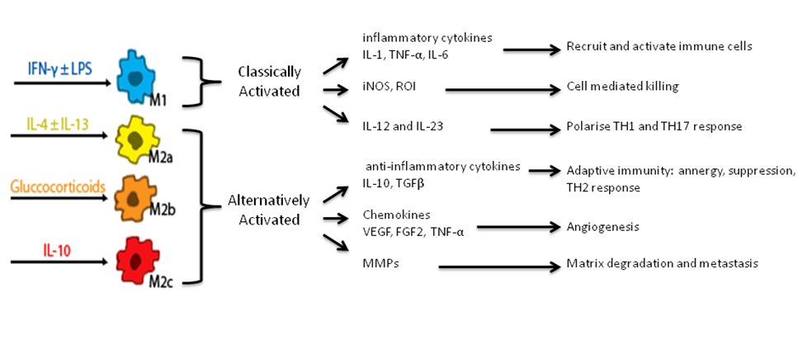
Figure 1 - Mechanisms of macrophage differentiation and their functional outcomes.
Depending on the mode of activation, macrophages will have different tumour outcomes. Classically activated macrophages function to actively fight tumours while alternatively activated macrophages are associated with wound healing and repair, giving them characteristics that are in line with a pro-tumour response. This is dependent on the cytokines and molecules that they produce.

Classically activated macrophages differentiate in response to IFN-γ either alone or in conjunction with bacterial stimuli such as LPS. When activated they are known as M1 macrophages and they have functional properties that elicit a TH1 and TH17 response. To polarise the TH1 and TH17 response they have high levels of IL-12 (Interleukin 12), IL-23 (Interleukin 23) and low IL-10 (Interleukin 10) expression . They also produce reactive oxygen and nitrogen intermediates for effective cell mediated killing and they can up-regulate the inflammatory cytokines IL-1β (Interleukin 1-beta), TNFα (Tumour necrosis factor alpha) and IL-6 (Interleukin 6). Their overall response is to effectively kill cells and microorganisms whilst attracting other immune cells to the area and activating them . Within a tumour, they exhibit anti-tumour functionality.
Continually strong inflammatory responses elicited by M1 macrophages can result in surrounding tissue damage if it is not effectively controlled . Once the area is cleared of any immediate danger, a wound healing response is required. Here the alternative pathway of activation can inhibit excessive inflammatory responses from occurring through differentiation of macrophages to an M2 phenotype. M2 macrophages are typically more diverse and may exhibit a range in phenotypes. They show low levels of IL-12 and IL-23 and high IL-10 . Further differences arise depending upon their mode of activation and three pathways have been identified. IL-4 and IL-13, gluccocorticoids or IL-10 induce differentiation of macrophages to M2a, b or c respectively. The exact differences between each of the M2 classes of macrophages have not been well characterised. It has been suggested that M2a show instances of wound healing through the release of growth factors and encouragement of angiogenesis . M2c on the other hand enable immune suppression by encouraging a TH2 response that will up-regulate regulatory T cells and myeloid derived suppressor cells . Further models suggest that there are intermediates between the M2 classes of macrophages and some phenotypes may overlap . The presence of M2 macrophages within a tumour are consequently favourable for its growth. Their wound healing functionality can facilitate in metastasis, angiogenesis and immune suppression.

In advanced prostate cancer there are an increased number of tumour associated macrophages
Presence of macrophages in tumours can reflect the progression of a tumour. Diagnosis based on macrophage presence varies depending on the tumour type and their ability to induce differentiation of macrophages to the M2 class. In colorectal carcinomas, increased macrophage infiltration gives a positive indication of long term survival . Within prostate cancer, however, macrophage presence has been associated with variable prognosis .
Results proposed by Shimura et al. indicated reduced infiltration was associated with cancer progression. Their conclusions were formed on the basis of macrophage infiltration in the total tissue area. However, their analysis of malignant areas as opposed to adjacent benign areas of the tumour showed the opposite trend. Malignant areas thus contained an increased density of macrophages. This was further correlated with a higher gleason score, reflective of later stages of cancer progression . This suggests that tumour associated macrophages (TAMs) may be attracted to malignant sites away from adjacent tissues where they can further facilitate in tumour progression.
Attraction of macrophages into the malignant areas in late stage prostate cancer has been demonstrated in vitro. Malignant prostate cancer cell lines, such as the C4-2 androgen independent line, had upregulated CCL2 . In vivo, levels of CCL2 were correlated with both greater macrophage infiltration and a higher gleason score . M2 macrophages can further upregulate the CCL2 chemokine to further attract more monocytes to the site maintaining a positive feedback loop of attraction. These results indicate that at later stages of progression more macrophages can infiltrate the tumour.
Functional studies of macrophages have not yet been achieved in prostate cancer models. This, however, has been analysed for breast cancer by looking at tumour growth when macrophages are absent. By creating a mouse knockout for the macrophage colony stimulating factor (CSF-1) macrophages were able to be sufficiently ablated. It was observed that a reduction in macrophages resulted in less metastasis and reduced progression .

Prostate tumour associated macrophages act in a pro-tumour manner
The progression of prostate cancer as mediated through macrophages is achieved by increasing metastasis, growth and angiogenesis. Increased VEGF (vascular endothelial growth factor), IL-8 (Interleukin 8) and bFGF (Basic Fibroblast Growth Factor) expression as released by macrophages can encourage lymphatic and circulatory infiltration in hypoxic areas of the tumour. This is M2 specific whereby M1 cytokine release, including IL-12 and high TNFα levels, are angiogenic inhibitors .
M2 expression of MMPs (matrix metalloproteinase) and Cathepsin proteases by the same macrophages can then increase chances of metastasis. Such proteins act to degrade the extracellular matrix and cellular contacts. This will increase cellular motility and their ability to spill into surrounding areas. Cathepsin is specifically regulated by IL-4, an activator of the M2 phenotype, indicating the link between tumour promoting capabilities associated with specific differentiation .

Altered gene expression in advanced tumours facilitates in establishing an environment to differentiate macrophages
Advanced tumours shows upregulation of genes acting in pathways associated with M2 differentiation molecule production. Instances of signalling molecules that differentiate macrophages to an M2 phenotype have been found in advanced tumours. Activation of the NF-κB (nuclear factor kappa B) signalling pathway in tumour cells following changes to gene expression is one modification commonly associated with tumour progression . NF-kB is able to sufficiently upregulate IL-10 secretion which is a differentiation factor responsible for M2c differentiation. Due to the high plasticity of macrophages, the existing M1 macrophages may undergo trans-differentiation to an M2 phenotype leading to further infiltration and pro-tumour functions .

Altered secretion could establish a specific tumour microenvironment for macrophage differentiation
As monocytes respond to secreted signals from tissues before differentiating, the tumour microenvironment is the greatest determinant of differentiation. One potential mechanism of cancer induced immune-suppression is the expression of metastasis associated genes that alter secretory pathways to modify the tumour microenvironment. Differentiation to an M2 phenotype by the tumour microenvironment alone has been demonstrated by taking conditioned media from prostate cancer cells and adding it to monocyte macrophage precursors . However, this does not narrow down what part of the secreted fraction is responsible for changes in differentiation, how those components are interacting or how it is changed in prostate cancer progression.

The role of caveolin-1 and PTRF in altering cellular secretion in the tumour microenvironment
One gene that alters secretion from prostate cancer is caveolin-1. It has been shown that caveolin-1 has increased expression in up to 30% of all advanced prostate cancers and this is associated with metastasis and poor prognosis . Caveolin-1 is a cholesterol binding membrane protein that is essential for formation of plasma membrane pits called caveolae . Interaction of caveolin-1 with polymerase 1 transcript release factor (PTRF) (also known as Cavin-1) is required for stable caveolae formation . In prostate cancer caveolin-1 is expressed without PTRF, leading to the aberant presence on flat plasma membrane (Figure 2). The mechanism of oncogenic caveolin-1 is not well defined but may involve alteration in signal transduction, cell migration or protein secretion.
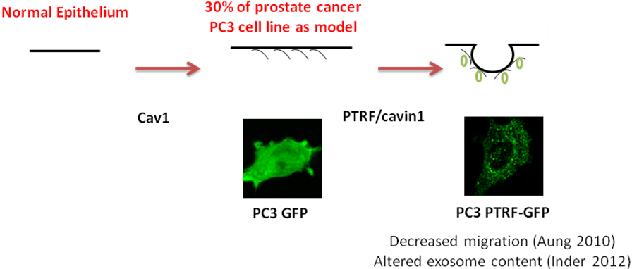
Figure 2 - The influence of PTRF and caveolin-1 on prostate cancer progression
In normal prostate epithelium, the plasma membrane lacks expression of both caveolin-1 and PTRF. Within prostate cancer up to 30% show caveolin-1 but not PTRF expression which localises to the flat plasma membrane. This can be modeled in the prostate cancer cell line PC3 that expresses caveolin-1 but not PTRF. Introduction of PTRF will enable formation of caveolae pits. Caveolin forms oligomers for the basic pit structure which is stabilized by PTRF binding. This reduces the metastatic potential of the tumour and will have effects on secretion. This has been demonstrated in the PC3 cell line with a GFP tag for PTRF
The metastatic PC3 cell line belongs to the 30% of prostate cancers that have caveolin-1 expression, but lack PTRF . Reintroduction of PTRF to PC3 cells reduced cell migration and anchorage-independent growth (unpublished), suggesting a reversal of metastatic potential. Interestingly, PTRF expression led to the reduction of a portion of secreted proteins that may mediate this effect (Table 1). Furthermore, proteins that are implicated in macrophage attraction and pro-tumour effects are altered, such as Macrophage migration inhibitory factor .

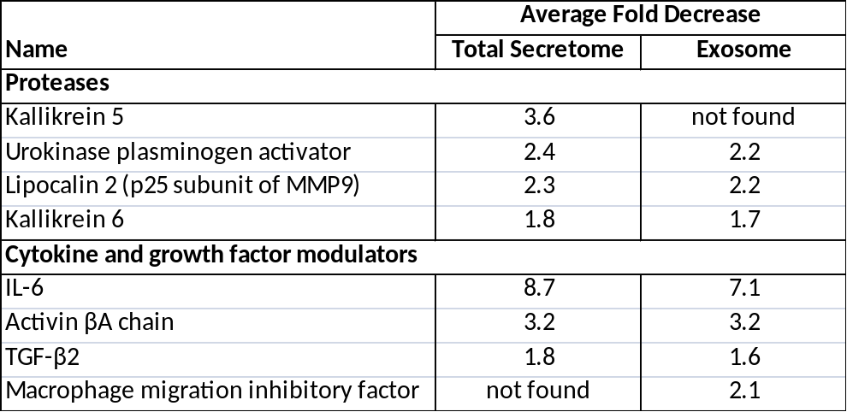
Table 1 - Ectopic PTRF expression in PC3 cells reduces protein secretion via exosomes.
Total protein from the secretome and prostasome fractions was quantitated by stable isotype labelling with amino acids in cell culture (SILAC). Several of the proteins identified are correlated with prostate cancer progression and aberrant bone metabolism.

Exosomes secreted in the tumour microenvironment provide a stable means to provide cellular communication
One specific component of the soluble fraction secreted by cells are exosomes (also referred to as prostasomes in the case of prostate cells). These small vesicles range in size from 30-100nm and are derived from the late endosomes of most cell types. Inward budding of the endosome will form a multivesicular body comprised of multiple exosomes filled with cytosol. This provides a stable environment for the storage of mRNA, miRNA and proteins. Subsequent fusion of the MVB with the plasma membrane will spill the contents into the surrounding cytosol. This method of release is the defining factor for classification as exosomes (reviewed in . This is different to microvesicles which bud directly from the plasma membrane .
After release, they can then be carried throughout the body or act through paracrine signalling to communicate with surrounding cells. Exosomes have been detected in multiple biological fluids, with prostate exosomes being commonly identified in urine. Within prostate cancer, urine samples show increased numbers of exosomes that contain prostate specific antigen (PSA), the biomarker for prostate cancer progression
The content of exosomes depends on the cell that they are derived from, and include proteins, mRNA, miRNA and lipids . Alterations to a cell, such as those that become cancerous can develop a new exosome signature . Single genes can also affect the exosome content, as in the example of PTRF expression in PC3 cells . As with the whole secretome, such exosomes contain proteins likely to affect the differentiation and attraction of macrophages, potentially contributing to prostate cancer progression (see table 1).
Exosomes, however, provide a further means to carry differentiation reagents that cannot be transported just through the extracellular milieu. Molecules such as miRNA and mRNA must be transported within a microvesicle to prevent degradation. These could facilitate in direct genetic reprogramming for trans-differentiation within macrophages. Alterations to pro-tumoral phenotypes has been demonstrated in TAMs whereby expression of miR-511-3p reduced anti-tumoural functions .

In order for exosomes to convey messages to other cells, they must interact with target cells. This can be achieved through interaction with target cell surface receptors, fusion with the plasma membrane or endocytosis and subsequent release of content into the cytoplasm by unknown mechanisms. The efficiency of such uptake may be modulated by cell surface proteins contained on the exosome. Presence of galectin-5 glycosyation patterns on exosome cell surface proteins has been shown to decrease the ability for macrophages to uptake exosomes through phagocytosis . Alternatively, interaction of exosomal ICAM-1 (Intracellular adhesion molecule) with LFA-1 (Lymphocyte Function-Associated Antigen 1) can enable exosomes to interact with cells through direct plasma fusion .

Hypotheses
This project will examine the hypothesis that PTRF expression in PC3 cells modulates the immune microenvironment via exosomes. Specifically, PC3 exosomes will enable differentiation of macrophages to the pro-tumour phenotype, while PTRF expression will alter the content of exosomes to attenuate this activity (Figure 3).
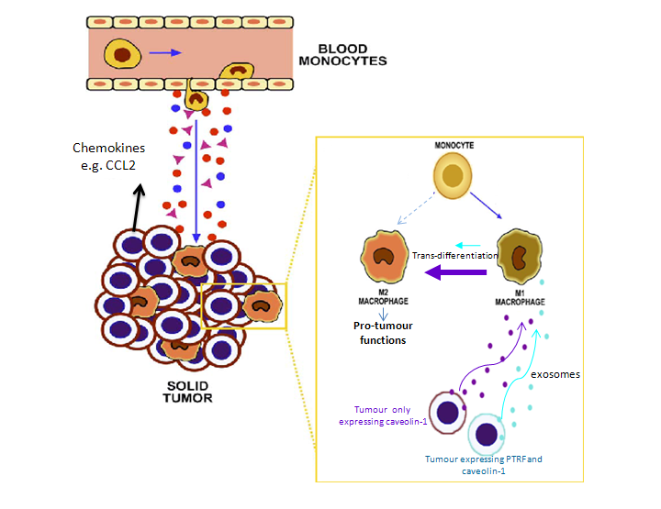
Figure 2 – Proposed model of macrophage trans-differentiation
The tumour secretes factors that enable increased attraction of macrophages to the site. Once in the tumour microenvironment, macrophages can take on an M1 or M2 phenotype. However, due to their plasticity they can trans-differentiate from one to the other. In advanced stages of prostate cancer, cells that express caveolin alone may contribute to an increased degree of trans-differentiation to the M2 pro-tumour phenotype. This may be achieved through altered exosomal content and deliver to M1 macrophages. (Adapted from Sica et al., 2006)

Aims
- To determine if exosomes derived from advanced prostate cancer cells (PC3) can induce polarization of macrophages to the pro-tumour (M2) phenotype through trans-differentiation and understand whether this is modulated by the expression of PTRF.
- To further characterise exosomes derived from PC3 cells with or without PTRF in their proteins, mRNA and miRNA to determine possible mechanisms for macrophage differentiation.
- To determine how the exosome-target cell interaction occurs and the effects on this due to PTRF expression.

Methods

Aim 1: Do exosomes induce macrophage differentiation?

Cellular model as a basis for prostate cancer progression
A PC3 cell line that has been stably transfected with a GFP or PTRF-GFP construct will be used. PC3 cells are an androgen-independent prostate cancer model that expresses caveolin-1 but not PTRF, which reflects the expression pattern of advanced prostate cancer. Upon reintroduction of PTRF, caveolae are able to form and the cells exhibit reduced cell migration and anchorage-independent growth

Exosome induced differentiation of macrophages

Exosome collection
In order to analyse whether exosomes are able to induce differentiation of macrophages, THP1 cells will be treated with exosomes extracted from PC3 cells with or without PTRF. Exosomes are collected from conditioned media after a 36 hour incubation period. This is achieved through filtration and a series of differential centrifugations. Levels consistent with endogenous exosome levels will be utilised in treatments .

Treatment of THP1 cells
As positive controls, THP-1 cells will be differentiated into M1, M2a or M2c phenotypes following published methods. THP-1 cells are a human acute monocytic leukemia cell line that act as the macrophage precursor . Wells will be plated with 1x10⁵ THP-1 cells whereby different treatments will be added.
To establish the controls, the treatments will be added to cells in serum free media. Various publications utilise the differentiation inducer PMA in conjunction with, LPS and IFN-γ for M1 differentiation, IL-13 and IL-4 for M2a or IL-10 for M2c. . Furthermore, a control with just PMA will be used. Optimisation of protocols will be used to ensure a maximum number of cells undergo differentiation for given concentrations in a time period that enables exosomes to interact with cells.
Treatment with exosomes will then be carried out in two ways. To determine whether the exosomes facilitate in the direct differentiation from precursor monocytes to their mature macrophage phenotype, exosomes will solely be added to THP1 cells. If they are able to induce differentiation, as analysed by the proportion of cells that become adherent, gene expression will be determined.
Within the tumour microenvironment there often exists an M1 population . If the cancer is to then progress, it must be able to trans-differentiate or remove the existing M1 population. To determine whether existing populations can be trans-differentiated by the exosomes, THP1 cells will first be differentiated to M1 macrophages by treating with PMA and adding exosomes derived from PC3 cells at a later stage.

Determination of differentiation status
Analysis of the THP-1 differentiation into macrophages will be carried out with quantitative real-time RT-PCR (RT-qPCR). A number of candidate genes that have been shown to have variable expression amongst the macrophage sub-populations will be analysed. Primers for the typical markers of classical and alternative activation, IL-12, IL-23 and IL-10, will be primarily used. Genes specific to M2a and M2c will also be analysed in conjunction with this to determine whether they are trans-differentiated to a certain subset. This will include CD14 for M2c differentiation and CD23 for M2a differentiation . While previous studies have identified differentiation to an M2 phenotype, this is rarely linked to a specific class. Furthermore, by narrowing down the M2 subset this potentially enables identification of the signal causing differentiation.
The use of RT-qPCR is dependent on the selection of reliable reference genes. PMA induced differentiation of THP-1 can result in typical housekeeping genes showing variable expression. As such, both ACTB and RPL37A will be used as they have been validated for use in similar treatments .
Results may be further verified with cytokine ELISA to monitor whether the upregulation is carried through to the protein level. Here, cytokines released into the media will be analysed 24 hours after differentiation according to published methods.

Aim 2: How do the exosomes differ in PC3 cells with or without PTRF?

Analysis of exosome material
RNA will be prepared from exosomes and integrity confirmed with use of an Agilent Bioanalyser . The mRNA and miRNA content of exosomes will be profiled by RNAseq using NextGen sequencing through collaboration with Dr Brooke Gardiner (UQ Centre for Clinical Genomics). Libraries will be prepared for exosomal miRNA and mRNA in separate cDNA libraries. Relative expression will be calculated by comparing transcript abundance in the presence or absence of PTRF in the cell of origin. Sequence tags will be mapped against the human reference genome (Hg19). Functionality of highly upregulated or downregulated mRNA or miRNA will be determined as a means to understand subsequent effects of paracrine signalling achieved by exosome interactions.
Proteomic analysis on purified exosomes will also be carried out by Dorothy Loo (UQDI Clinical Proteomics Facility) using an optimized protocol compared to a previous study (Inder et al. 2012). Exosomes will be separated on SDS-PAGE to a 8mm distance and stained with colloidal coomassie. One millimetre slices will be made and proteins digested with trypsin overnight. Peptides will be extracted and analysed by nano-liquid chromatography-coupled tandem mass spectrometry.

Aim 3: How are exosomes internalised by macrophages?

Establishment of THP-1 exosome uptake
If it is found that exosomes are able to differentiate macrophages, the mechanisms that they interact with the THP-1 cells will be established. This will be achieved by fluorescently labelling exosomes with a lipophilic fluorescent dye and monitoring their interaction with THP-1 cells treated with PMA. If exosomes are able to directly differentiate THP1 cells to macrophages, exosome interaction with undifferentiated THP-1 cells will also be monitored. To quantify this, the fluorescence intensity will be measured at different time points and their surface interaction or uptake monitored with confocal microscopy. Target cells will be immuno-labelled with α-tubulin to aid visualization of the cell. The efficiency of exosome uptake will be used to compare exosome treatments from cells with or without the expression of PTRF.

Mechanisms responsible for exosome uptake
If there is an interaction, exosome uptake will be monitored under varied conditions to identify possible mechanisms facilitating in their uptake. Based on bioinformatic analysis, candidate exosome surface proteins will be identified and blocked with antibodies before allowing them to interact with THP-1 cells or M1 macrophages.

Data Analysis
Data analysis for RT-qPCR will be carried out using the pfaffl method . Two way anova will be used to compare different treatment groups to controls. One way anova will also be used to compare fluorescence at different time points for the exosome interaction experiments.

Timeline
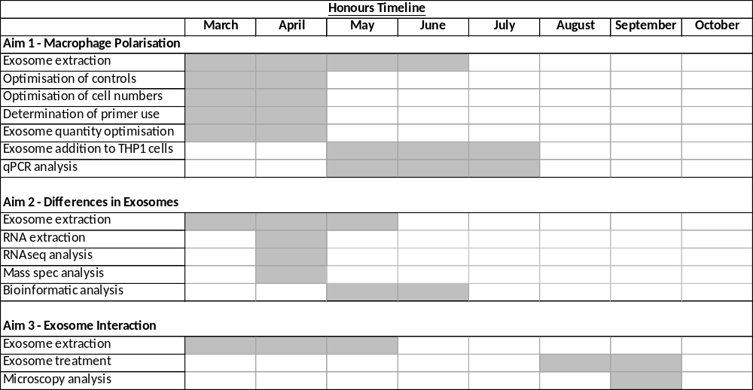
As much of this project is dependent on the use of exosomes, the timeline for completion of each aim relies on their extraction. Aim 2 will be completed first due to the minimal number of exosomes required. This can be done in line with optimisation of differentiation protocols and establishment of controls. Determination of macrophage differentiation will be established before moving on to analysis of the way that the exosomes interact (table 2).
Table 2 - Honours timeline
Estimated time of completion for each of the aims in this honours project. Aim 1 will be completed before progressing onto Aim 3. Aim 2 will also be completed in line with Aim 1.

Significance
Prostate cancer is responsible for more than 900,000 deaths annually . In order to become fatal, the cancer must develop an immunosuppressive tumour microenvironment. This project has the overall goal to further understand the way that the tumour microenvironment aids in establishing a pro-tumour immune response.
By understanding the way the macrophage pro-tumour immune response is initiated, mechanisms can be identified to counteract changes for potential therapies. If exosomes induce trans-differentiation to the pro-tumour phenotype, prevention of their uptake could provide treatment. As exosomes are required throughout the whole body, therapies must be specific to tumour microenvironments. This study will further identify differences in exosomal content that arise from cancer progression enabling tumour specific therapies to be generated. Identification of exosomal contents will also aid in determining signals for macrophage trans-differentiation. Treatments could therefore be established without affecting exosome uptake. Identification of pathways may further aid the advancement of immunosuppressive drugs.
Differences in protein, miRNA or mRNA examined in exosomes derived from advanced prostate cancer cells could have the potential to form diagnostic measures for prostate cancer progression. As exosomes are readily available for collection from urine samples, this could provide a non-invasive way to determine the stage of cancer . Identification of effective markers for prostate cancer progression will facilitate in tailoring treatments based on the cancers aggressiveness.
Overall, this study will identify targets to diagnose cancer and prevent the pro-tumour immune response. If therapies are generated for such targets, this will effectively aid in reducing the number of cancer related deaths.

References
Aung, C.S., Hill, M.M., Bastiani, M., Parton, R.G., and Parat, M.O. (2011). PTRF-cavin-1 expression decreases the migration of PC3 prostate cancer cells: role of matrix metalloprotease 9. Eur J Cell Biol 90, 136-142.
Barrès, C., Blanc, L., Bette-Bobillo, P., André, S., Mamoun, R., Gabius, H.-J., and Vidal, M. (2010). Galectin-5 is bound onto the surface of rat reticulocyte exosomes and modulates vesicle uptake by macrophages. Blood 115, 696-705.
Batista, B.S., Eng, W.S., Pilobello, K.T., Hendricks-Muñoz, K.D., and Mahal, L.K. (2011). Identification of a Conserved Glycan Signature for Microvesicles. Journal of Proteome Research 10, 4624-4633.
Biswas, S.K., and Mantovani, A. (2010). Macrophage plasticity and interaction with lymphocyte subsets: cancer as a paradigm. Nat Immunol 11, 889-896.
Caras, I., Tucureanu, C., Lerescu, L., Pitica, R., Melinceanu, L., Neagu, S., and Salageanu, A. (2011). Influence of tumor cell culture supernatants on macrophage functional polarization: in vitro models of macrophage-tumor environment interaction. Tumori 97, 647-654.
Cheng, L., Montironi, R., Bostwick, D.G., Lopez-Beltran, A., and Berney, D.M. (2012). Staging of prostate cancer. Histopathology 60, 87-117.
Cheng, L., Zincke, H., Blute, M.L., Bergstralh, E.J., Scherer, B., and Bostwick, D.G. (2001). Risk of prostate carcinoma death in patients with lymph node metastasis. Cancer 91, 66-73.
Conroy, H., Mawhinney, L., and Donnelly, S.C. (2010). Inflammation and cancer: macrophage migration inhibitory factor (MIF)—the potential missing link. QJM 103, 831-836.
Corn, P.G., and Thompson, T.C. (2010). Identification of a novel prostate cancer biomarker, caveolin-1: Implications and potential clinical benefit. Cancer management and research 2, 111-122.
Duijvesz, D., Luider, T., Bangma, C.H., and Jenster, G. (2011). Exosomes as Biomarker Treasure Chests for Prostate Cancer. European Urology 59, 823-831.
Dunn, G.P., Old, L.J., and Schreiber, R.D. (2004). The three Es of cancer immunoediting. Annu Rev Immunol 22, 329-360.
Eken, C., Gasser, O., Zenhaeusern, G., Oehri, I., Hess, C., and Schifferli, J.A. (2008). Polymorphonuclear neutrophil-derived ectosomes interfere with the maturation of monocyte-derived dendritic cells. J Immunol 180, 817-824.
Funderburg, N.T., Jadlowsky, J.K., Lederman, M.M., Feng, Z., Weinberg, A., and Sieg, S.F. (2011). The Toll-like receptor 1/2 agonists Pam3CSK4 and human β-defensin-3 differentially induce interleukin-10 and nuclear factor-κB signalling patterns in human monocytes. Immunology 134, 151-160.
Gocheva, V., Wang, H.-W., Gadea, B.B., Shree, T., Hunter, K.E., Garfall, A.L., Berman, T., and Joyce, J.A. (2010). IL-4 induces cathepsin protease activity in tumor-associated macrophages to promote cancer growth and invasion. Genes & Development 24, 241-255.
Gould, M.L., Williams, G., and Nicholson, H.D. (2010). Changes in caveolae, caveolin, and polymerase 1 and transcript release factor (PTRF) expression in prostate cancer progression. The Prostate 70, 1609-1621.
Gurtner, G.C., Werner, S., Barrandon, Y., and Longaker, M.T. (2008). Wound repair and regeneration. Nature 453, 314-321.
Hill, M.M., Bastiani, M., Luetterforst, R., Kirkham, M., Kirkham, A., Nixon, S.J., Walser, P., Abankwa, D., Oorschot, V.M.J., Martin, S., et al. (2008). PTRF-Cavin, a Conserved Cytoplasmic Protein Required for Caveola Formation and Function. Cell 132, 113-124.
Inder, K.L., Zheng, Y.Z., Davis, M.J., Moon, H., Loo, D., Nguyen, H., Clements, J.A., Parton, R.G., Foster, L.J., and Hill, M.M. (2012). Expression of PTRF in PC-3 Cells Modulates Cholesterol Dynamics and the Actin Cytoskeleton Impacting Secretion Pathways. Molecular & Cellular Proteomics 11.
Izhak, L., Wildbaum, G., Jung, S., Stein, A., Shaked, Y., and Karin, N. (2012). Dissecting the autocrine and paracrine roles of the CCR2-CCL2 axis in tumor survival and angiogenesis. PLoS One 7, e28305.
Jemal, A., Bray, F., Center, M.M., Ferlay, J., Ward, E., and Forman, D. (2011). Global cancer statistics. CA Cancer J Clin 61, 69-90.
Kim, Y.-J., Park, S.-J., and Broxmeyer, H.E. (2011). Phagocytosis, a Potential Mechanism for Myeloid-Derived Suppressor Cell Regulation of CD8+ T Cell Function Mediated through Programmed Cell Death-1 and Programmed Cell Death-1 Ligand Interaction. The Journal of Immunology 187, 2291-2301.
Lasser, C., Seyed Alikhani, V., Ekstrom, K., Eldh, M., Torregrosa Paredes, P., Bossios, A., Sjostrand, M., Gabrielsson, S., Lotvall, J., and Valadi, H. (2011). Human saliva, plasma and breast milk exosomes contain RNA: uptake by macrophages. Journal of Translational Medicine 9, 9.
Li, Y., Kong, D., Ahmad, A., Bao, B., and Sarkar, F.H. (2012). Targeting Bone Remodeling by Isoflavone and 3,3′-Diindolylmethane in the Context of Prostate Cancer Bone Metastasis. PLoS ONE 7, e33011.
Lin, E.Y., Nguyen, A.V., Russell, R.G., and Pollard, J.W. (2001). Colony-Stimulating Factor 1 Promotes Progression of Mammary Tumors to Malignancy. The Journal of Experimental Medicine 193, 727-740.
Lissbrant, I.F., Stattin, P., Wikstrom, P., Damber, J.E., Egevad, L., and Bergh, A. (2000). Tumor associated macrophages in human prostate cancer: relation to clinicopathological variables and survival. Int J Oncol 17, 445-451.
Loberg, R.D., Ying, C., Craig, M., Day, L.L., Sargent, E., Neeley, C., Wojno, K., Snyder, L.A., Yan, L., and Pienta, K.J. (2007). Targeting CCL2 with Systemic Delivery of Neutralizing Antibodies Induces Prostate Cancer Tumor Regression In vivo. Cancer Research 67, 9417-9424.
Maeß, M., Sendelbach, S., and Lorkowski, S. (2010). Selection of reliable reference genes during THP-1 monocyte differentiation into macrophages. BMC Molecular Biology 11, 90.
Mantovani, A., Allavena, P., Sozzani, S., Vecchi, A., Locati, M., and Sica, A. (2004a). Chemokines in the recruitment and shaping of the leukocyte infiltrate of tumors. Seminars in Cancer Biology 14, 155-160.
Mantovani, A., Sica, A., and Locati, M. (2005). Macrophage Polarization Comes of Age. Immunity 23, 344-346.
Mantovani, A., Sica, A., Sozzani, S., Allavena, P., Vecchi, A., and Locati, M. (2004b). The chemokine system in diverse forms of macrophage activation and polarization. Trends Immunol 25, 677-686.
Mantovani, A., Sozzani, S., Locati, M., Allavena, P., and Sica, A. (2002). Macrophage polarization: tumor-associated macrophages as a paradigm for polarized M2 mononuclear phagocytes. Trends in Immunology 23, 549-555.
Mitchell, P., Welton, J., Staffurth, J., Court, J., Mason, M., Tabi, Z., and Clayton, A. (2009). Can urinary exosomes act as treatment response markers in prostate cancer? Journal of Translational Medicine 7, 4.
Mosser, D.M., and Edwards, J.P. (2008). Exploring the full spectrum of macrophage activation. Nat Rev Immunol 8, 958-969.
Murray, P.J., and Wynn, T.A. (2011). Protective and pathogenic functions of macrophage subsets. Nat Rev Immunol 11, 723-737.
Nathan, C., and Ding, A. (2010). Nonresolving Inflammation. Cell 140, 871-882.
Nilsson, J., Skog, J., Nordstrand, A., Baranov, V., Mincheva-Nilsson, L., Breakefield, X.O., and Widmark, A. (2009). Prostate cancer-derived urine exosomes: a novel approach to biomarkers for prostate cancer. Br J Cancer 100, 1603-1607.
Nolte-‘t Hoen, E.N.M., Buschow, S.I., Anderton, S.M., Stoorvogel, W., and Wauben, M.H.M. (2009). Activated T cells recruit exosomes secreted by dendritic cells via LFA-1. Blood 113, 1977-1981.
Ong, S.-M., Tan, Y.-C., Beretta, O., Jiang, D., Yeap, W.-H., Tai, J.J.Y., Wong, W.-C., Yang, H., Schwarz, H., Lim, K.-H., et al. (2012). Macrophages in human colorectal cancer are pro-inflammatory and prime T cells towards an anti-tumour type-1 inflammatory response. European Journal of Immunology 42, 89-100.
Parton, R.G., and Simons, K. (2007). The multiple faces of caveolae. Nat Rev Mol Cell Biol 8, 185-194.
Pfaffl, M.W. (2001). A new mathematical model for relative quantification in real-time RT-PCR. Nucleic acids research 29, e45.
Romagnani, S. (1999). Th1/Th2 cells. Inflamm Bowel Dis 5, 285-294.
Scarpino, S., Stoppacciaro, A., Ballerini, F., Marchesi, M., Prat, M., Stella, M.C., Sozzani, S., Allavena, P., Mantovani, A., and Ruco, L.P. (2000). Papillary carcinoma of the thyroid: hepatocyte growth factor (HGF) stimulates tumor cells to release chemokines active in recruiting dendritic cells. Am J Pathol 156, 831-837.
Shimura, S., Yang, G., Ebara, S., Wheeler, T.M., Frolov, A., and Thompson, T.C. (2000). Reduced infiltration of tumor-associated macrophages in human prostate cancer: Association with cancer progression. Cancer Research 60, 5857-5861.
Smyth, M.J., Dunn, G.P., and Schreiber, R.D. (2006). Cancer Immunosurveillance and Immunoediting: The Roles of Immunity in Suppressing Tumor Development and Shaping Tumor Immunogenicity. In Advances in Immunology, G.D. James P. Allison, and W.A. Frederick, eds. (Academic Press), pp. 1-50.
Squadrito, Mario L., Pucci, F., Magri, L., Moi, D., Gilfillan, Gregor D., Ranghetti, A., Casazza, A., Mazzone, M., Lyle, R., Naldini, L., et al. (2012). miR-511-3p Modulates Genetic Programs of Tumor-Associated Macrophages. 1, 141-154.
Tjiu, J.W., Chen, J.S., Shun, C.T., Lin, S.J., Liao, Y.H., Chu, C.Y., Tsai, T.F., Chiu, H.C., Dai, Y.S., Inoue, H., et al. (2009). Tumor-associated macrophage-induced invasion and angiogenesis of human basal cell carcinoma cells by cyclooxygenase-2 induction. J Invest Dermatol 129, 1016-1025.
Tsuchiya, S., Yamabe, M., Yamaguchi, Y., Kobayashi, Y., Konno, T., and Tada, K. (1980). Establishment and characterization of a human acute monocytic leukemia cell line (THP-1). Int J Cancer 26, 171-176.
Vuletic, S., Dong, W., Wolfbauer, G., Tang, C., and Albers, J.J. (2011). PLTP regulates STAT3 and NFκB in differentiated THP1 cells and human monocyte-derived macrophages. Biochimica et Biophysica Acta (BBA) - Molecular Cell Research 1813, 1917-1924.
Yoshida, S., Ono, M., Shono, T., Izumi, H., Ishibashi, T., Suzuki, H., and Kuwano, M. (1997). Involvement of interleukin-8, vascular endothelial growth factor, and basic fibroblast growth factor in tumor necrosis factor alpha-dependent angiogenesis. Mol Cell Biol 17, 4015-4023.

